
ASTRAQUANTUM TECH
SUMMER OF CYBERSECURITY 2026
WEEK 8 PRACTICAL ASSIGNMENT
Digital Forensics — Disk Image Investigation with Autopsy
Evidence • Artifact Analysis • Deleted Files • Timeline Thinking
Student Name | Muhammad Raza
Date | September 29, 2026
Instructor | AstraQuantum Tech Team
Program | AstraQuantum Tech – Summer of Cybersecurity 2026

Table of Contents
1. Case Overview 3
2. Evidence Source 3
3. Tools Used 3
4. Investigation Steps 3
5. Key Artifact Found 3
6. Evidence Screenshot(s) 4
7. Interpretation 5
8. Limitations / What the Evidence Does Not Prove 6
9. Conclusion 6
2–3 Sentence Case Summary 6

1. Case Overview
This investigation analyzes a digital forensic image of a USB drive belonging to “Charlie,” an employee within the M57 Patents corporate scenario. The objective is to utilize digital forensic methodologies to ingest the disk image, recover artifacts, and analyze deleted files to determine potential user activity prior to the drive's acquisition.

2. Evidence Source
Image Filename: charlie-work-usb-2009-12-11.E01
Source Website: Digital Corpora - M57 Patents Scenario (https://downloads.digitalcorpora.org/corpora/scenarios/2009-m57-patents/)
Format: E01 (EnCase Expert Witness Format)
Download Date: September 29, 2026

3. Tools Used
Autopsy (Version 4.23.1): A graphical digital forensics platform used to ingest the E01 image, parse the file system, recover deleted artifacts, and extract metadata.
Operating System: Windows 11 (host machine for forensic analysis).

4. Investigation Steps
- A dedicated case directory (Week8_CT24138) was created to ensure evidence isolation.
- The original charlie-work-usb-2009-12-11.E01 image was added to Autopsy as a read-only Data Source to preserve evidence integrity.
- Ingest modules were configured and executed, specifically targeting Recent Activity, Deleted Files, Keyword Search, and Data Carving.
- The logical file system was examined, focusing on the “Deleted Files” category to identify attempts at data destruction or concealment.

5. Key Artifact Found
Artifact: A deleted file record named Charlie_2009-11-20_1303_Sent.txt.
Location: Found within the Deleted Files > All category in the logical view, originally located in /img_charlie-work-usb-2009-12-11.E01/vol_vol2/Email/.
Metadata: The file size is recorded as 0 bytes, and the File Name Allocation is marked as “Unallocated.” The MAC (Modified, Accessed, Created) timestamps are wiped (0000-00-00 00:00:00), though the MD5 hash remains visible in the metadata record.

6. Evidence Screenshot(s)
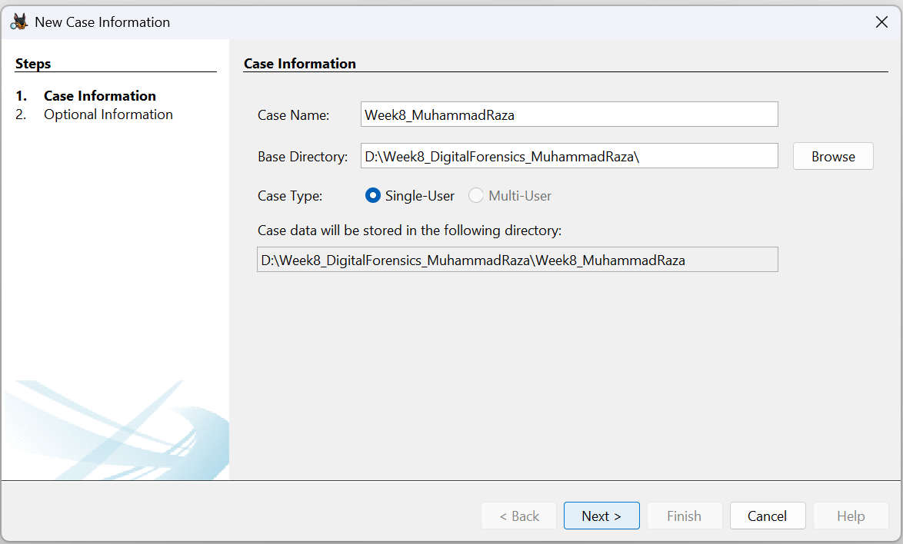
Screenshot 1 - Autopsy case created successfully in the designated working directory.
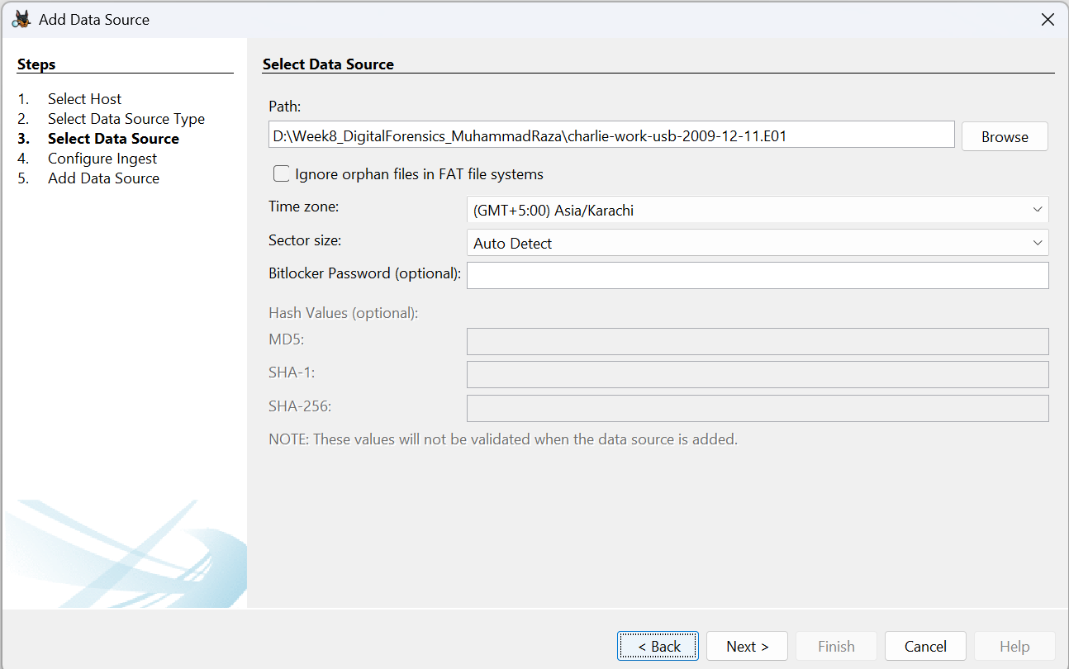
Screenshot 2 - Forensic image charlie-work-usb-2009-12-11.E01 successfully added as a data source.
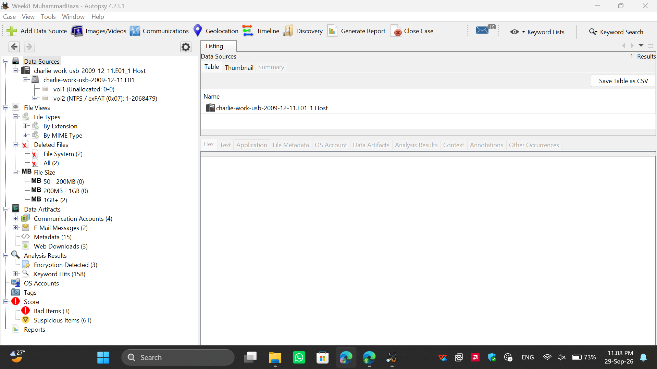
Screenshot 3 - Ingest results showing the populated data tree, including Deleted Files and Data Artifacts.
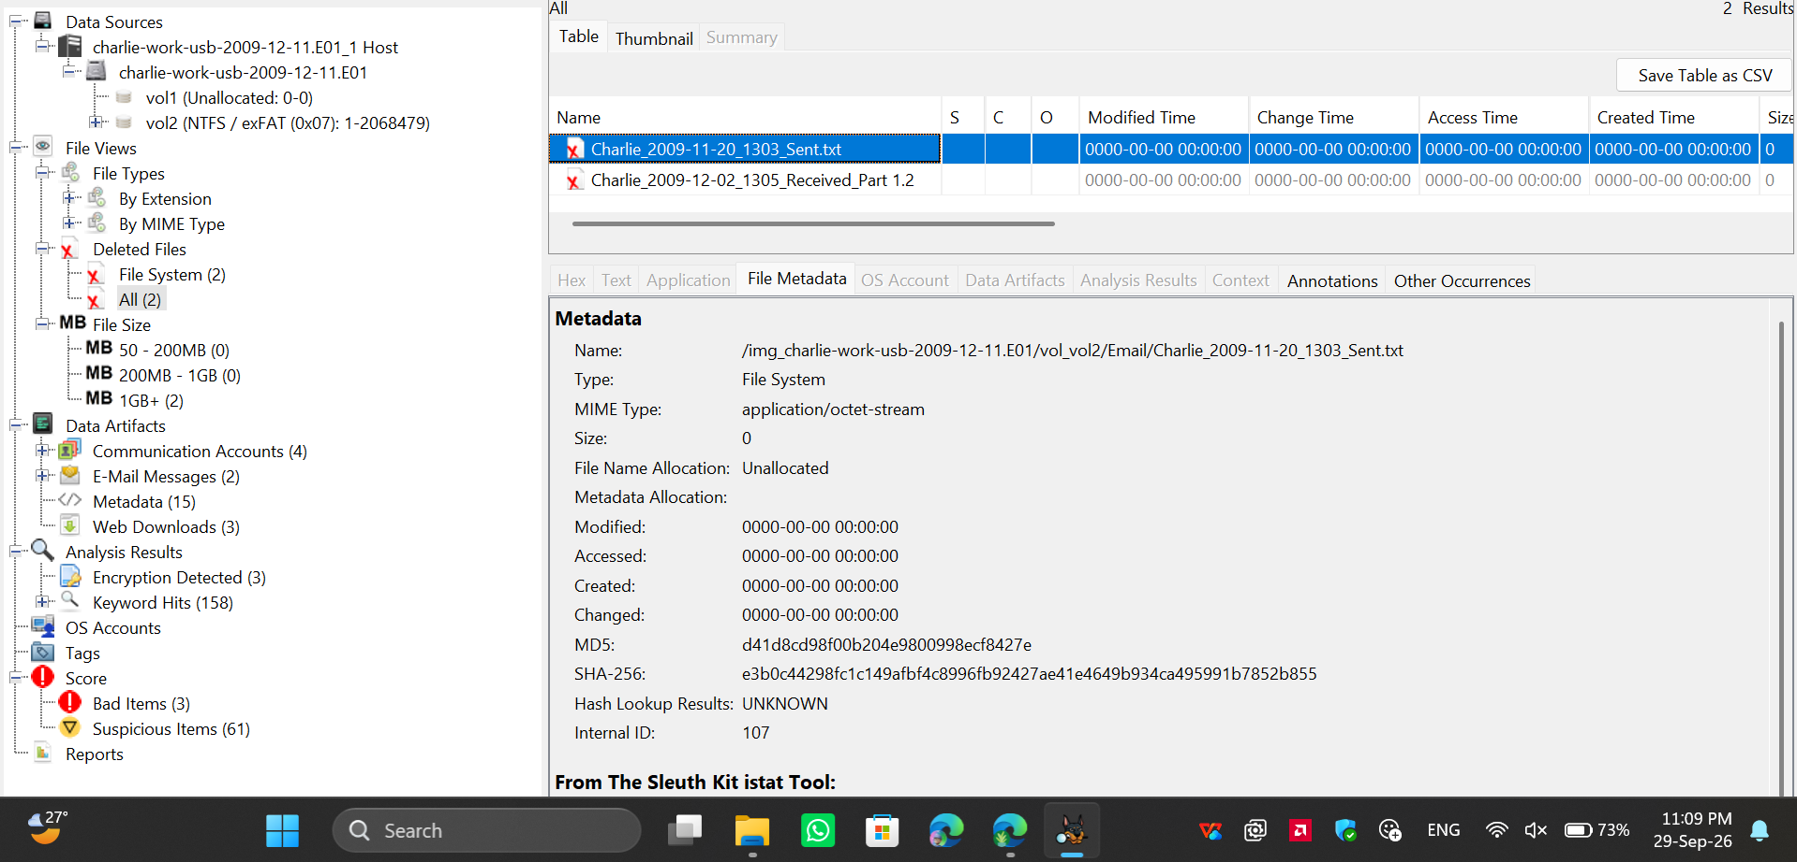
Screenshot 4 - The selected deleted artifact (Charlie_2009-11-20_1303_Sent.txt) showing unallocated status and zeroed timestamps.

7. Interpretation
What does the artifact show?: The artifact proves that a text file named Charlie_2009-11-20_1303_Sent.txt previously existed on Charlie's USB drive within an “Email” directory.
What user action might it indicate?: The file name convention strongly suggests it is an exported or saved email sent by Charlie on November 20, 2009. The fact that it is now in the “Deleted Files” view with a 0-byte size and zeroed timestamps indicates the user intentionally deleted the file from the USB drive.
What can be said with confidence?: We can confidently state that a file with this specific name was stored on this USB drive and subsequently deleted, leaving only its file-system entry behind.

8. Limitations / What the Evidence Does Not Prove
While the file name suggests it contains an email sent by Charlie, the artifact alone does not prove the actual contents of that email, who the recipient was, or whether the contents were sensitive. Furthermore, because the MAC timestamps are zeroed out, we cannot conclusively determine the exact date and time the user deleted the file from the drive.

9. Conclusion
I analyzed the charlie-work-usb-2009-12-11.E01 disk image from the Digital Corpora M57 Patents scenario using Autopsy. I found a deleted file record named Charlie_2009-11-20_1303_Sent.txt, which indicates that the user saved and subsequently deleted an exported email record from their work USB drive. This artifact does not by itself prove the contents of the email or whether the deletion was an attempt to hide illicit activity.
2–3 Sentence Case Summary
I analyzed the charlie-work-usb-2009-12-11.E01 image using Autopsy. I found a deleted file, Charlie_2009-11-20_1303_Sent.txt, which indicates the user saved and later deleted an exported email from the USB drive. This artifact does not by itself prove the contents of that email or the user's motive for deleting it.

